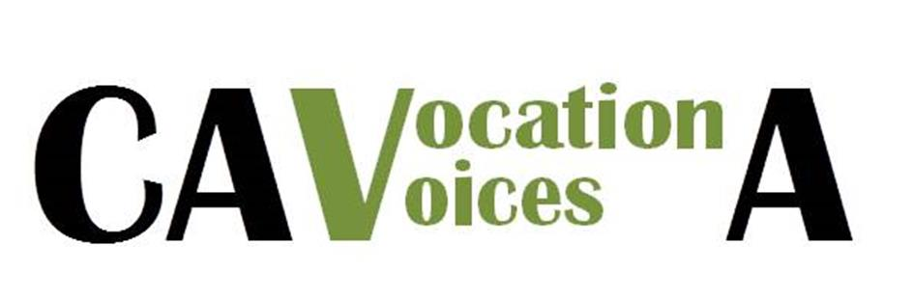

Sr. Hanna Paradowska, CSFN Celebrates Silver Jubilee

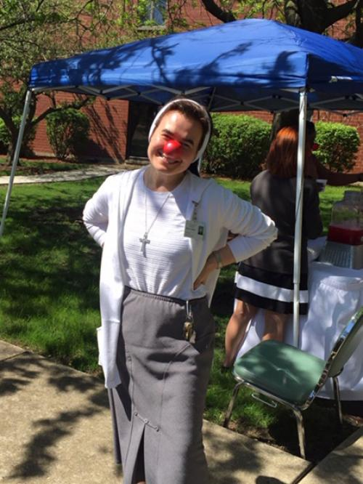

**Sr, Hanna Paradowska, CSFN**

**Holy Family of Nazareth**

There is a verse from scripture that has been with Sr. Hanna from the very beginning of her religious life: “Everyone who has given up houses or brothers or sisters or father or mother or children or lands for the sake of my name will receive a hundred times more, and will inherit eternal life” (Mt 19:29). Looking back on the last quarter century, Sr. Hanna believes this verse still holds true for her journey as a Sister of the Holy Family of Nazareth. “Because of the gift of faith and because of my response to God’s call, I have had the privilege to minister to so many.”

A board-certified chaplain with an MA in spirituality from Loyola University in Chicago, Sr. Hanna currently serves in pastoral care at Ascension Living’s Casa San Carlo Retirement Community in Northlake, IL. Over the last 12 years in various pastoral care ministries, she has been a peaceful and calming presence in hectic and emotional situations. Sr. Hanna also volunteers in detention centers ministering to immigrants. She says she has “had the privilege to minister to families… in their darkest hours.”

Mother Theresa of Calcutta (now St. Theresa) inspired Sr. Hanna, as she began to explore the possibility of entering religious life. After researching various communities, she was drawn to the hospitality, family spirit, daily Eucharistic adoration, and simplicity of the Sisters of the Holy Family of Nazareth. “I think that our Nazareth charism and ministry to families is so vital and needed today,” she says. “God - in His Son - chose to be present to people in their needs, their weaknesses, their poverty, and their ordinary life experiences.”